BCSE202L Data Structure and Algorithm

Dr. Durgesh Kumar, Assistant Professor, SCOPE, VIT Vellore

## CodeBlocks + Visual Code studio set up for Running a C Program

1. Downloads Code Blocks with MinGW

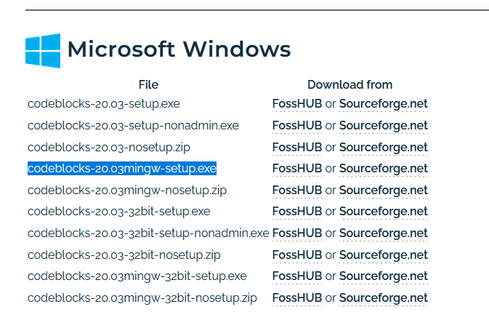

1. Install Code Blocks with MinGW
2. Add PATH C:\Program Files\CodeBlocks\MinGW\bin to to System PATH
3. Open Visual code studio and do CTRL + SHift + x ( to search for C/C++ Extension)
4. Install the C/C++ Microsoft Extension

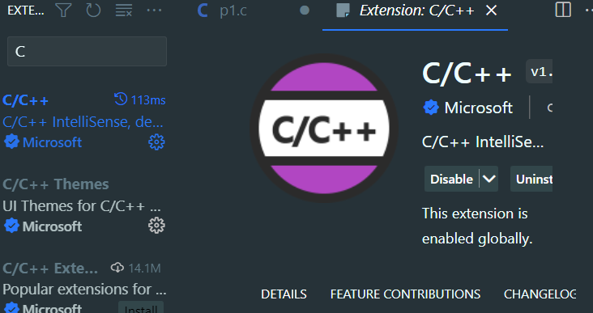

## 2. Running a C Program with Visual Code Studio

1. Create a folder where you will save your C program. I am creating a folder in my D Drive, with the name DSA .
2. Open Visual Code and open that folder.

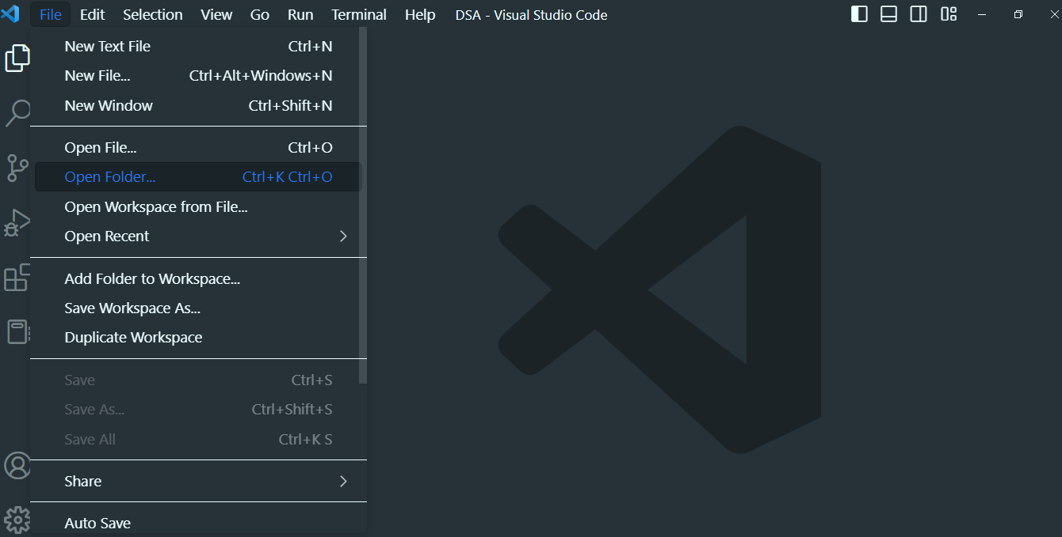

1. Click on New file and save it as first.c

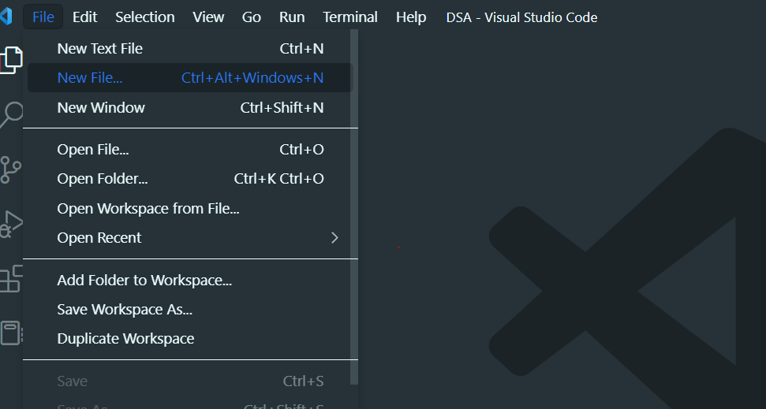

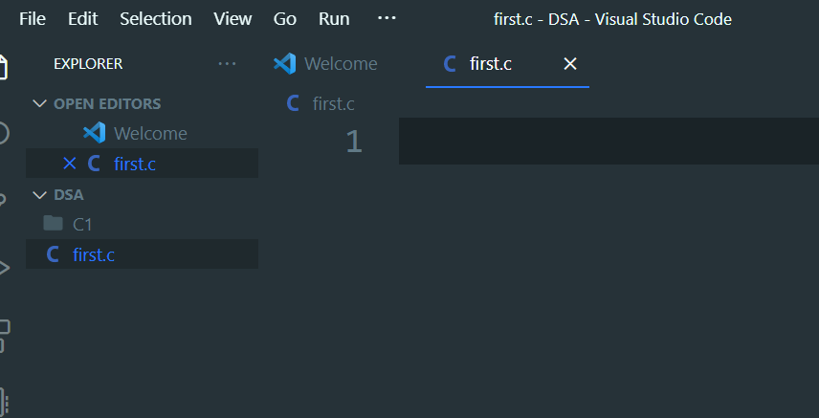

1. Write a sample a program as below and save it using (CTRL+S) :

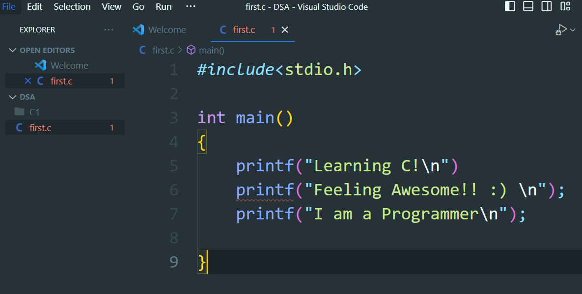

1. Search … on the top header and click … -> Terminal -> New Terminal as shown below

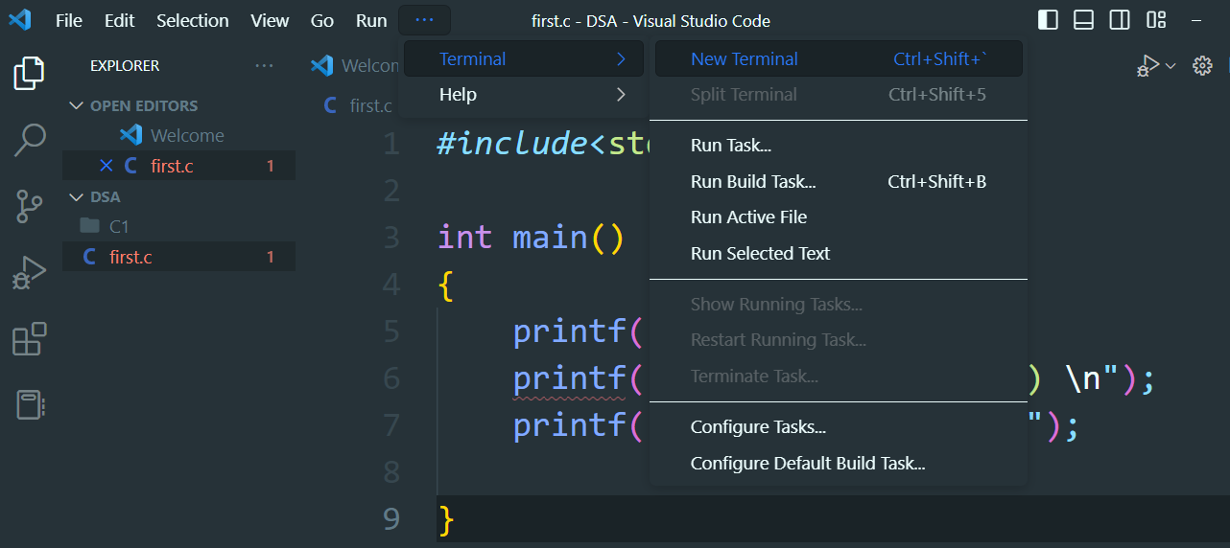

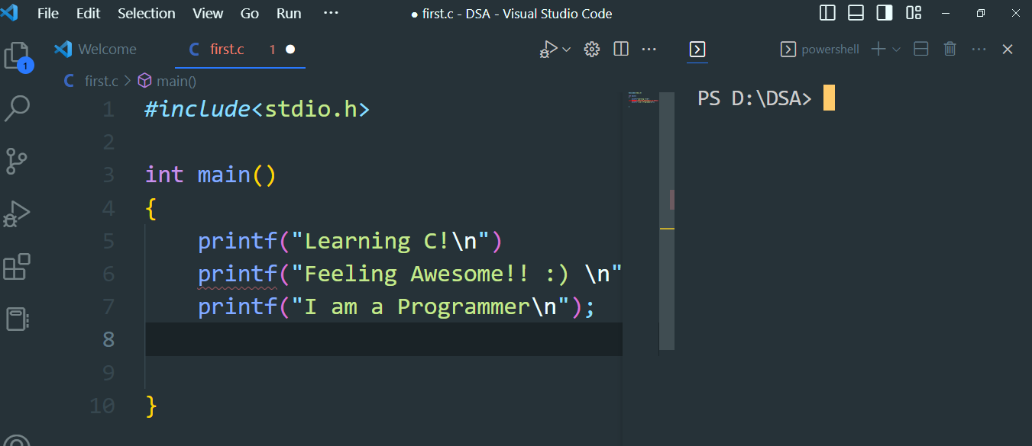

1. Type ls on the terminal to get the list of files present in the current directory.

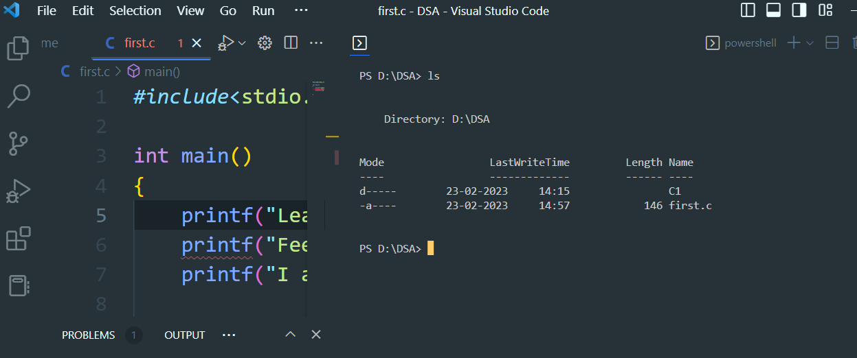

You will see first.c in the listed files

1. Compile your C file using gcc.
   1. gcc first.c

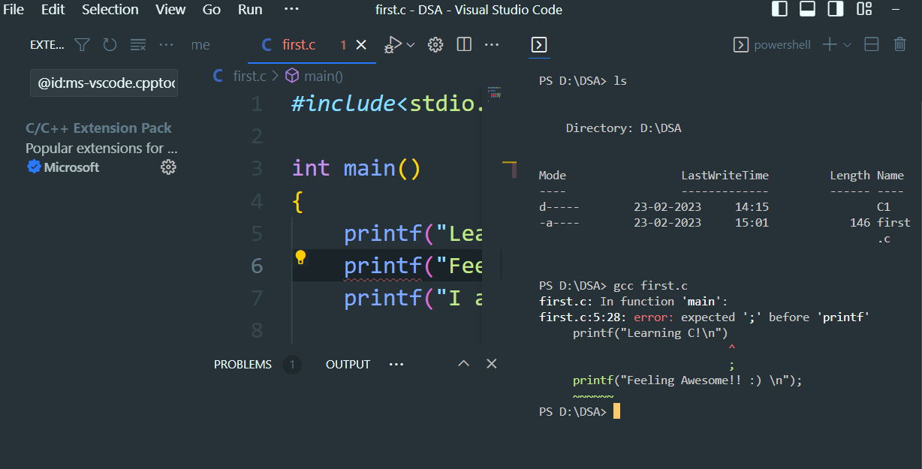

* 1. We are getting an error semicolon missing after the printf line. We will fix the error, save it and re-compile it.
  2. When we run ls command again, we can see a.exe (a.out in case of linux or Mac) is generated.

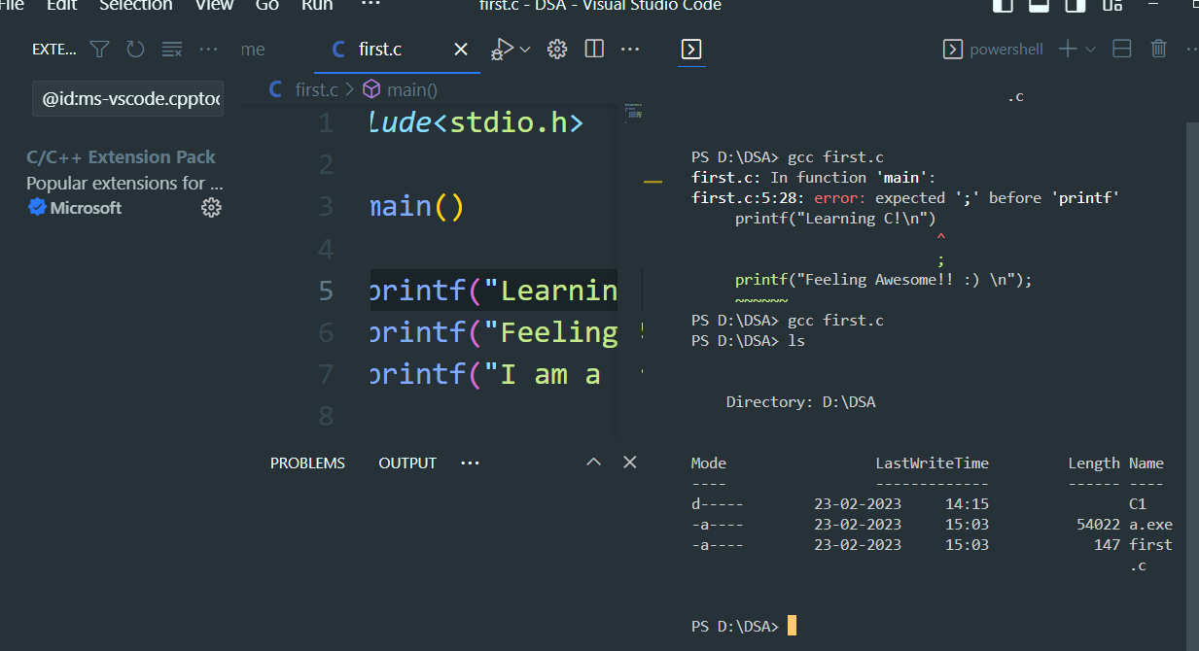

1. Running Compiled binary file
   1. .\a.exe (For Windows)

./a.exe (For Linux/Mac)

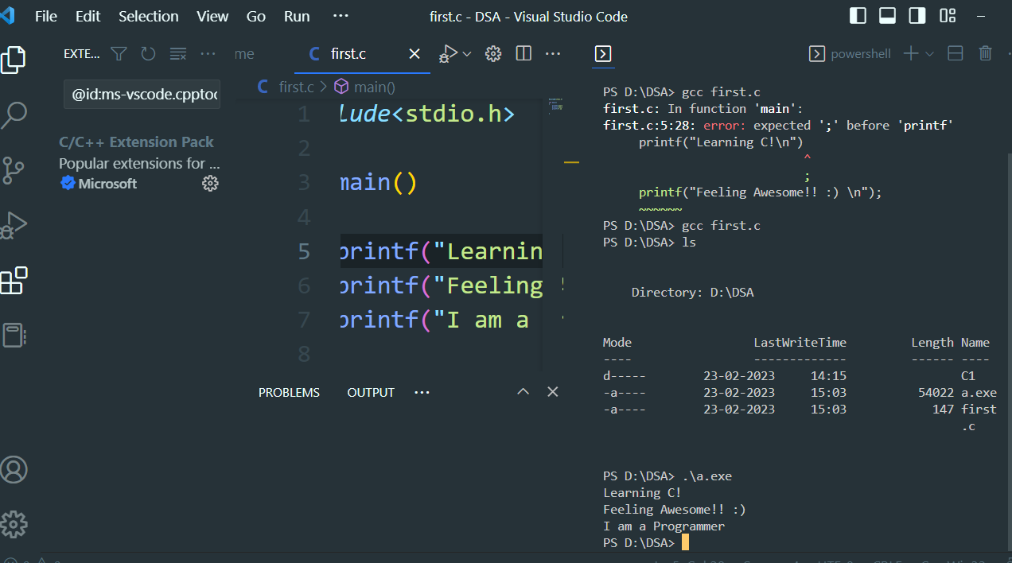

Congratulations! You have compiled and executed your first C Program on your computer.

Extra tip: Saving the compiled file to your preferred name instead of a.exe or a.out as default.

For Windows

1. gcc first.c -o first.exe
2. .\first.exe

URL: